Assignment-1

Name: Mokshith V Sharma

Roll No: AUFS009104

Email: mokshithvsharma@gmail.com

Contact Number: 9650083492

Practice Commands

1. ls: Displays the files, directories present in the current repository. The following command helps us to view the files present in the current repository



2. ls –l: If we want the contents (files, directories) in the repository to be displayed in a single column format use ls –l

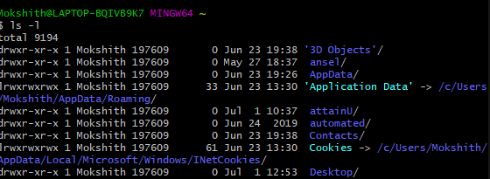

3. pwd: gives the present working directory

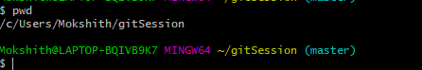

4. touch: touch: will create an empty file in the folder/directory specified. Touch will only work when the folder is already present in the current repository.

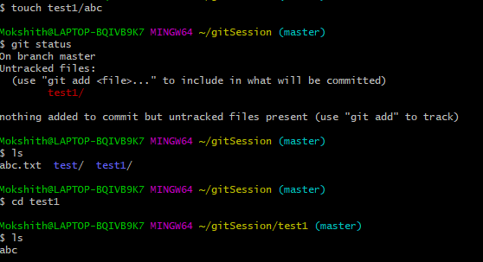

5. cd .. (Change Directory to previous directory): The following command will navigate to up one directory

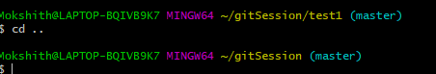

6. cd(Change Directory To Home) :The following command will navigate you to home directory

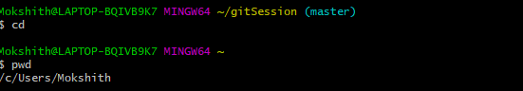

7. cd ~ (Change Directory to Home) : The following will navigate you to home directory

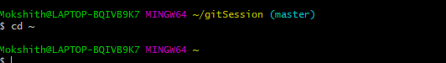

8. mkdir (make Directory): The following command will make a directory in the repository in which we can save a file.

